

Image Editing Application in Python

A Final Assignment

presented to: Ms. Lois Villamor

in completion of the Subject Requirement
for Computer Science Practical Examination

By:
<Your complete name> <Ex. Taylor Alison Swift>
<Your Class> <Ex. 12.1>

National Student Number: 00000000000

SEKOLAH BUKIT SION
2025 – 2026
Acknowledgements

My deepest gratitude and respect, first and foremost, goes to my Lord JESUS Christ, my saviour. I am saved by your grace and enjoys your mercies day after day. My life has become meaningful and is directed by your purposes for you have made me your child. I am forever grateful.
I would like to express my profound gratitude to my parents for the unconditional love they have given to me throughout my life. Thank you, Dad and Mom for all the support I have been enjoying thus far. This enabled me to achieve this milestone and learn so much because you have afforded me the avenue to accomplish these things.

Blah, blah. Blah…

TABLE OF CONTENTS

Title
Acknowledgements
Table of Contents
Chapter 1 Introduction 1
Background of the Study 1
Statement of the Problem 2
Hypothesis 2
Chapter 2 Pseudocode 3
Chapter 3 Program Codes 9
Chapter 4 Sample Outputs 23
The Making 29

<You may edit this page according to the correct paging of your paper>
Note: Page numbers should appear only on non-chapter pages. For Pages that has CHAPTER 1, CHAPTER 2, etc, these should not have page numbers but are still included in the counting of pages and correct page numbers are listed in the TABLE OF CONTENTS.

CHAPTER 1
INTRODUCTION

Background
Photo Editing has been a constant source of amazement from just about anyone for a long time until digital cameras were invented. Even at the advent of digital cameras, photo editing has always been a work done by professionals. And, it still is, I would say.
This changed when cameras became a staple part of every handphones where a photo can be snapped and posted in social media right away. This leaves, little to no time to edit photos before they are published online.
Attaching a camera to handphone democratised the image curation and publication to the mass. It also demolished established businesses like Kodak and Fuji films. While it was invented to ease social media posting, admittedly, it also had its negative effects. One of which is the constant stream of unedited photos that appear online.

Blah. Blah. Blahh…

Statement of the Problem
Given the prolific use of photos, in lieu of texts, handheld devices like phones that has a camera attached has given rise to the need of quick fix editing.

Blah. Blah. Blahhh..

Hypothesis
To address this problem, photo editing has to be done quickly and precisely. To which, I have built the application to address this need.
This photo editing application has an accessible interface the enables users to do the editing quickly and ensure published images produce what the user intended to publish.
Blah. Blah. Blahhh…

CHAPTER 2
PSEUDOCODE

DECLARE Variable1 : INTEGER
DECLARE Variable2 : STRING[25]
Blah. Blah. Blah…

CHAPTER 3
PROGRAM CODES

import ttkbootstrap as ttk
from tkinter import filedialog, messagebox, colorchooser
from PIL import Image, ImageTk, ImageFilter
class PhotoEditor:
def __init__(self, master):
self.master = master
self.master.title("Photo Editor")

Blah. Blah. Blahhh..

CHAPTER 4
SAMPLE OUTPUTS

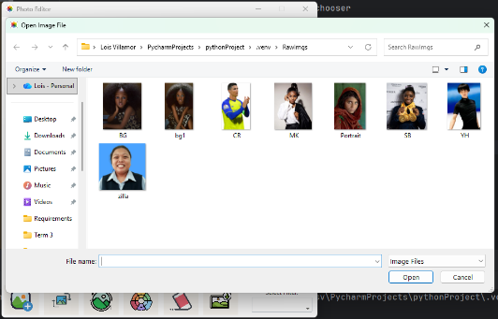
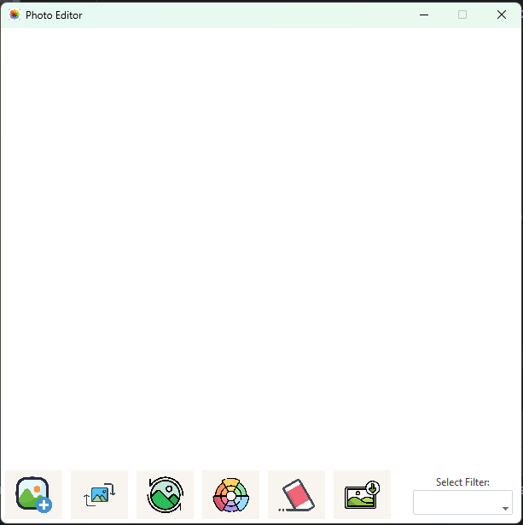
Figure 1: Main interface Figure 2: Open image
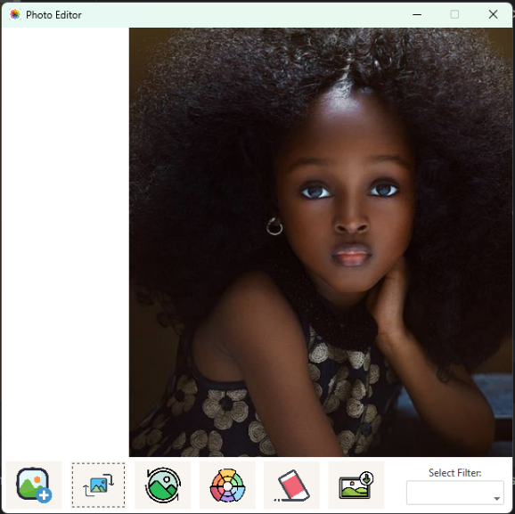
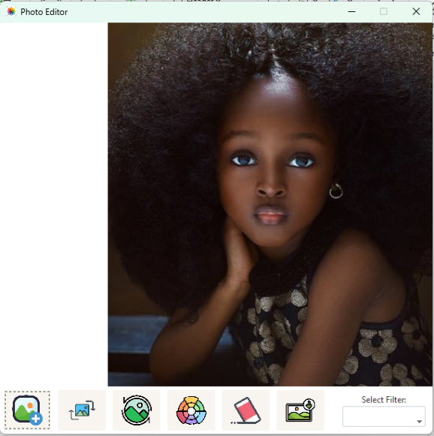

Figure 3: Image opened Figure 4: Flipped image

The Making
Please fill this page with photos of you doing the project.
Minimum 3 photos (you, in the library(research), in the lab (coding), at home (doing the project, hopefully..))
You may also add any other photo to commemorate. Something candid, photo with friends, teachers, your pet fish, etc.
Just make sure that it shows modesty and is appropriate.

